

School of Computer Science and Engineering
Computer Engineering Software Engineering
Faculty of Engineering & Technology
Jain Global Campus, Kanakapura Taluk - 562112
Ramanagara District, Karnataka, India

2024-2025
(VI Semester)

A Project Report on

“Movie Note App”

Submitted in partial fulfilment for the award of the degree of

Bachelor of Technology
in
COMPUTER ENGINEERING
(Software Engineering)

Submitted by

Darshika Mishra
22BTRSN011

Under the guidance of

Dr. Janarthanan Sekar
Assistant Professor

Department of Computer Engineering Software Engineering
School of Computer Science & Engineering
Faculty of Engineering & Technology
JAIN (Deemed to-be University)


Department of Computer Engineering Software Engineering
School of Computer Science & Engineering
Faculty of Engineering & Technology
Jain Global Campus, Kanakapura Taluk - 562112
Ramanagara District, Karnataka, India
CERTIFICATE
This is to certify that the project work titled “Movie Note App” is carried out by Darshika Mishra (22BTRSN011) a bonafide student of Bachelor of Technology at the School of Engineering & Technology, Faculty of Engineering & Technology, JAIN (Deemed-to-be University), Bangalore in partial fulfillment for the award of degree in Bachelor of Technology in Computer Engineering Software Engineering, during the year 2024-2025.

Dr. Janarthanan Sekar | Dr. Santhosh S. | Dr. Geetha G
Asst Professor  Dept. of CE-SE,  Faculty of Engineering & Technology  JAIN (Deemed to-be University)  Date:  Date: | Program Head,  Computer Engineering  Software Engineering,  Faculty of Engineering & Technology  JAIN (Deemed to-be University)  Date: | Director,  School of Computer Science & Engineering  Faculty of Engineering & Technology  JAIN (Deemed to-be University)  Date:

Name of the Examiner Signature of Examiner
1.

2.
DECLARATION
I, Darshika Mishra(22BTRSN011) student of 6th semester B.Tech in Computer Engineering Software Engineering, at School of Engineering & Technology, Faculty of Engineering & Technology, JAIN (Deemed to-be University), hereby declare that the inhouse project work titled “Movie Note App” has been carried out by me and submitted in partial fulfilment for the award of degree in Bachelor of Technology in Computer Engineering Software Engineering during the academic year 2024-2025. Further, the matter presented in the work has not been submitted previously by anybody for the award of any degree or any diploma to any other University, to the best of our knowledge and faith.

Darshika Mishra Signature
USN: 22BTRSN011

Place: Bangalore

Date:

ACKNOWLEDGEMENT

It is a great pleasure for me to acknowledge the assistance and support of a large number of individuals who have been responsible for the successful completion of this project work.
First, I take this opportunity to express my sincere gratitude to Faculty of Engineering & Technology, JAIN (Deemed to-be University) for providing me with a great opportunity to pursue my Bachelors / Master’s Degree in this institution.
I am deeply thankful to several individuals whose invaluable contributions have made this project a reality. I wish to extend my heartfelt gratitude to Dr. Chenraj RoyChand, Chancellor, for his tireless commitment to fostering excellence in teaching and research at Jain (Deemed-to-be-University). I am also profoundly grateful to the honorable Vice Chancellor, Dr. Raj Singh for their unwavering support.
I am grateful to several persons because of whom this project was possible. I want to express our
sincere gratitude to Dr. Chandraj Roy Chand for his untiring efforts towards quality teaching
and research that have resulted in coveting graded autonomy A ++ for Jain (Deemed-to-be
University). I want to thank the honorable Vice Chancellor Dr. Raj Singh, and Dr. Dinesh
Niland, Director of CMS Business School. Dr. Harold Patrick, the Dean of CMS Business
School. They have instilled in us the qualities and abilities that are immensely invaluable and
indispensable to us in our future endeavors.
I am grateful to several persons because of whom this project was possible. I want to express our
sincere gratitude to Dr. Chandraj Roy Chand for his untiring efforts towards quality teaching
and research that have resulted in coveting graded autonomy A ++ for Jain (Deemed-to-be
University). I want to thank the honorable Vice Chancellor Dr. Raj Singh, and Dr. Dinesh
Niland, Director of CMS Business School. Dr. Harold Patrick, the Dean of CMS Business
School. They have instilled in us the qualities and abilities that are immensely invaluable and
indispensable to us in our future endeavors.
I extend my sincere gratitude to Dr. Hariprasad S A, Director of the Faculty of Engineering & Technology, and Dr. Geetha G, Director of the School of Computer Science & Engineering within the Faculty of Engineering & Technology, for their constant encouragement and expert advice.
It is a matter of immense pleasure to express my sincere thanks to Dr. Santhosh S., Program Head, Computer Engineering Software Engineering, School of Computer Science & Engineering Faculty of Engineering & Technology for providing right academic guidance that made my task possible.
I would like to thank our guide Dr. Janarthanan Sekar Assistant. Professor, Dept. of Computer Science and Engineering, for sparing his/her valuable time to extend help in every step of my work, which paved the way for smooth progress and fruitful culmination of the project.
I am also grateful to my family and friends who provided me with every requirement throughout the course.
I would like to thank one and all who directly or indirectly helped me in completing the work successfully.

Signature of Student
ABSTRACT
The Movie Note App is a personal movie journaling platform crafted to help users systematically record, organize, and reflect on their movie-watching experiences. Initially developed with core functionalities, the app allows users to manually add movie entries, storing important information such as title, release year, genre, and personal reviews. It provides an intuitive interface for editing, deleting, and searching through a curated movie list, promoting an organized viewing archive.
To streamline user interaction, the Movie Note App is integrated with the OMDB API, allowing users to fetch complete movie details automatically by simply entering the movie title. This reduces manual data entry, enhances accuracy, and enriches the movie database experience. The structured and searchable layout ensures users can easily navigate through their collection.
In the upcoming project milestones, the app will be enhanced with several additional features including a "Favorite" tagging system, sorting capabilities (by genre, year, or personal rating), a personal star-based rating system, and the creation of a "Watchlist" for tracking upcoming movies. Furthermore, a basic authentication module will be integrated to enable user-specific profiles and personalized data management.
Looking beyond the immediate scope, the Movie Note App has significant potential for future expansion. Planned improvements include implementing cloud synchronization to allow access across devices, integrating AI-based recommendation systems to suggest movies tailored to user preferences, and introducing social features such as collaborative watchlists, sharing notes with friends, and comparing reviews. Deeper API integrations with trending and popular movie databases can further enhance content discovery. Additionally, advanced viewing analytics could help users better understand their watching patterns and preferences over time.
In conclusion, the Movie Note App lays a strong foundation for becoming a comprehensive, intelligent, and social movie companion platform, evolving from a personal journal into a dynamic tool for movie lovers worldwide.

TABLE OF CONTENTS
Chapter 1
- Introduction
- Background & Motivation | 08
- Objective | 08
- Delimitation of research | 09
- Benefits of research | 09
Chapter 2
- LITERATURE SURVEY
- Literature Review | 10
- Inferences Drawn from Literature Review | 11
Chapter 3
- Problem Formulation and Proposed Work
3.1 Introduction | 12
3.2 Problem Statement | 12
3.3 System Architecture /Model | 13
3.4 Proposed Algorithms | 13
3.5 Proposed Work | 14
- Implementation
- Hardware Design and Implementation | 15
- Software algorithm | 16
Chapter 5
- Results And Discussion | 17
Conclusions And Future Scope | 19
References | 20
Appendices
Appendix – I | i-iii
Appendix – II | iv-vi
Information Regarding Student | vii

INTRODUCTION

1.1 Background & Motivation
In today’s era of endless streaming platforms and cinematic releases, movie enthusiasts often struggle to keep track of the films they have watched or plan to watch. Although various apps allow rating or basic tracking, most lack a personal touch — a space for personal notes, reflections, and detailed curation.
The Movie Note App is developed to bridge this gap by offering users a simple yet feature-rich platform to document their movie journeys. The motivation behind the app stems from the need for a personal, customizable, and intelligent system that not only logs movie information but also evolves with user preferences.
The integration of the OMDB API automates movie detail fetching, reducing manual effort and ensuring accuracy. Planned features like favorites, watchlists, and personal ratings further personalize the experience. As entertainment consumption becomes increasingly individualized, having a dedicated personal movie journal becomes not just helpful but essential.

1.2 Objective
The primary objectives of this project are as follows:
- To build an easy-to-use application that allows users to add, view, edit, and delete movie notes.
- To automatically fetch movie details using the OMDB API based on user input.
- To provide search and sort functionalities to manage large movie collections efficiently.
- To enable users to mark favorites and maintain a personal watchlist for upcoming movies.
- To implement a rating system for users to evaluate movies based on personal experience.
- To introduce user authentication, allowing separate profiles and personalized movie collections.
- To prepare the app for future cloud syncing and multi-device access.
- To lay the groundwork for AI-based recommendations and social sharing features in future versions.

1.3 Delimitation of Research
- The Movie Note App currently focuses only on movies and not TV shows or web series.
- OMDB API integration is limited to fetching basic movie details like title, year, genre, and plot — no deep metadata like cast bios or reviews yet.
- The app is built primarily for personal, single-user usage; multi-user collaboration and social interaction features are planned for future updates.
- Offline usage is currently restricted — real-time internet connection is required to fetch details via OMDB API.
- The app interface is optimized for desktop/laptop users at this stage; mobile optimization and responsive design will be considered later.

1.4 Benefits of Research
- Helps users systematically record and organize their movie-watching experiences in one place.
- Reduces manual entry effort through automated movie detail fetching using OMDB API, improving user experience.
- Promotes a personalized and reflective viewing habit by allowing users to add personal notes, ratings, and memories.
- Establishes a scalable foundation for adding future features like AI-driven recommendations, cloud syncing, and social movie sharing.
- Demonstrates how a simple application can evolve with APIs, authentication, and future integration of AI/analytics, making it a strong project for showcasing software development and scaling skills.

LITERATURE SURVEY

2.1 Literature Review
The evolution of digital entertainment tracking tools has expanded significantly over the past decade, primarily due to the rise of streaming platforms and the growing need for users to manage their consumption habits. Several applications such as IMDb, Letterboxd, and Trakt.tv provide users with the ability to log movies they have watched, rate them, and share opinions publicly. While these platforms offer a wide array of public reviews, rating systems, and social interaction features, they often focus more on external validation and popularity rather than providing a private, reflective space for personal notes and experiences.

Earlier research into personal media management applications highlights the importance of customization, simplicity, and ease of access. Traditional diary apps and journaling tools like Day One and Journey offer personal documentation facilities but are not specialized for movie tracking, making them less ideal for users who want a film-centric experience. Research by media behavior analysts has shown that users prefer lightweight, purpose-driven apps for single-genre content tracking rather than multi-purpose note-taking platforms. This insight motivated the creation of a specialized solution focusing solely on movies.

Integration with external movie databases, such as the Open Movie Database (OMDB) API or The Movie Database (TMDb) API, has proven to be an effective way to automate the data entry process. Several studies in software engineering have confirmed that reducing user effort in filling forms or repetitive manual input significantly increases application retention rates and user satisfaction. The OMDB API, used in this project, allows fetching of detailed movie data like the release year, genre, poster images, and a short plot description, ensuring that the app remains lightweight while still enriching the user experience.

Security and personalization are also crucial aspects of modern applications. Literature around user authentication systems, such as basic token-based authentication or OAuth systems, shows that users expect data privacy, especially when personal notes and preferences are involved. Though heavy security is not implemented at the prototype stage of this project, future integration of user profiles highlights awareness of privacy and tailored experiences, aligning with modern best practices.

Finally, emerging trends in entertainment tracking emphasize the growing potential of artificial intelligence and machine learning. Studies suggest that personalized content recommendations, automatic genre classification, and viewing analytics not only increase user engagement but also create a feedback loop that helps users discover new areas of interest. By laying the foundation for future AI integration, the Movie Note App aligns itself with the direction modern user-centric entertainment applications are taking, ensuring scalability and relevance in the longer term.

2.2 Inferences Drawn from Literature Review
Need for Personalization:
Existing platforms like IMDb and Letterboxd focus heavily on public interaction, highlighting the need for a personalized, private movie note-taking app that caters to individual users rather than a public audience.
Importance of Automation:
Studies show that automating data entry (through APIs like OMDB) greatly improves user experience and retention, validating the decision to integrate an external movie database in the Movie Note App.
Preference for Specialized Apps:
Users prefer single-purpose, lightweight applications over generic multi-functional tools, reinforcing the idea that a focused "movie journaling" app has better acceptance among target audiences.
Essential Role of User Data Privacy:
With growing awareness around data privacy, providing personalized profiles and secure login options is crucial even in seemingly simple apps to ensure user trust and comfort.
Future Trends Favor AI Integration:
Literature indicates that AI-driven recommendation systems and analytics are becoming key features for entertainment apps, suggesting that future scaling of the Movie Note App should align toward intelligent content suggestions and habit analysis.

PROBLEM FORMULATION AND PROPOSED WORK

3.1 Introduction
With the increasing volume of movies being watched today, users often struggle to keep a personalized and organized record of their viewing experiences. Existing platforms like IMDb and Letterboxd focus more on public reviews and ratings rather than providing private, customizable note-taking features. Manual data entry also adds to user fatigue. There is a clear need for a simple, efficient solution that automates movie detail fetching while offering users a private space for reflections, ratings, and watchlists.

3.2 Problem Statement
Current movie tracking platforms prioritize public ratings and social interactions, leaving little room for private, personalized movie records. Manual entry of movie details can be tedious and discourages regular use. There is a need for a lightweight, user-friendly application that automates the fetching of movie information, enables private note-taking, and supports organizing movies into watchlists and favorites. The solution should also provide a scalable foundation for future enhancements like cloud syncing and AI-based recommendations.

3.3 System Architecture / Model

Architecture Description:
The system is divided into three primary layers:
The Movie Note App follows a modular and layered architecture to ensure simplicity, scalability, and ease of future upgrades. The overall design is divided into three main layers:
1. Presentation Layer (Frontend / User Interface)
- This layer handles all user interactions.
- Users can search for a movie, view fetched details, add personal notes, assign ratings, and categorize movies into watchlists or favorites.
- The interface is designed for ease of use, offering minimalistic yet functional navigation.
2. Application Layer (Logic / Functional Core)
- This layer manages the core functionality of the app.
- It handles search requests by interacting with the OMDB API to fetch movie data based on user input.
- After retrieving the data, it processes and presents it to the user, while allowing additional actions like saving notes, ratings, and organizing lists.
- Internal validation (e.g., avoiding duplicate entries) and basic error handling (e.g., API failures) are managed here.
3. Data Layer (Storage / Database)
- Stores all user-created data locally or, in future extensions, via cloud storage (e.g., Firebase, AWS DynamoDB).
- This includes user notes, movie metadata, custom tags, favorites, watchlist statuses, and ratings.
- The data layer ensures persistence across sessions and prepares for future scalability to multi-device syncing.

3.4 Proposed Algorithms

Step-by-Step Algorithm:

1. User Input and Search
- The user enters the name (or partial name) of a movie they want to add or view.
- The app captures this input and prepares it for an API call.

2. Movie Data Fetching from OMDB API
- The app sends a request to the OMDB API with the movie name.
- If a matching movie is found, the API responds with movie details (title, year, genre, poster, plot, etc.).
- If the API fails, appropriate error handling is triggered (e.g., display "Movie not found" message).

3. Display and User Interaction
- Retrieved movie details are displayed neatly on the app interface.
- The user is allowed to add personal notes, assign custom ratings, or mark the movie as "Favorite" or "Watchlist."

4. Data Saving and Management
- Once the user adds notes or selects a status, the app stores this combined information (movie details + personal input) into local storage (e.g., a database or internal storage).
- Duplication checks ensure that the same movie isn't saved multiple times unless specifically updated.

5. Retrieval and Organization
- Users can search through saved movies, filter them (e.g., Favorites, Watchlist), view their notes, and update entries when needed.
- The system keeps the structure flexible to allow easy future expansion like cloud backup or multi-device access.

3.5 Proposed Work
To address the identified problem, the following work was proposed and completed:
The proposed work focuses on building an efficient, user-centric Movie Note Application that simplifies the process of recording and organizing personal movie experiences. The app integrates with the OMDB API to automate movie information fetching, reducing manual data entry and enhancing user experience. Along with basic search and data retrieval functionalities, the system will support personal note-taking, custom ratings, and classification into favorites and watchlists.
The application is designed with a modular architecture divided into presentation, application, and data layers, ensuring scalability and easy maintenance. Initially, the app will operate using local storage for saving user data, with future provisions to extend storage solutions to cloud services for multi-device synchronization.
Additional enhancements include the implementation of robust error handling for API failures, duplicate data prevention during saving, and flexible search/filter options for user convenience. In the long term, the app may incorporate features like machine learning-based movie recommendations, user authentication, cloud backup, and synchronization, thus scaling it towards a more intelligent and distributed system.
The proposed work ensures a balance between immediate deliverable features and a strong foundation for future growth and enhancement of the application.

IMPLEMENTATION

4.1 Hardware Design and Implementation

The development and testing of the Movie Note App require standard computing hardware capable of running development environments, API integrations, and local data storage efficiently. As the project is lightweight, it does not demand high-end specifications but needs reliable performance for smooth execution. Basic laptops or desktops with moderate RAM and storage are sufficient for building, testing, and running the application. Future scaling involving cloud services might demand additional hardware or cloud-based server access.

Hardware Requirements:
Component | Specification
Processor (CPU) | Minimum Intel Core i3 / AMD Ryzen 3 (Recommended: i5 or higher)
Memory (RAM) | Minimum 4GB RAM (Recommended 8GB or higher for faster multitasking)
Storage | At least 256 GB HDD (Recommended: 256 GB SSD for faster operations)
Display | 13-inch or larger screen (Recommended: Full HD 1080p resolution)
Internet Connectivity | Standard broadband or mobile data connection (minimum 2 Mbps)
Operating System | Windows 10/11, macOS, or any stable Linux distribution

4.2 Software Algorithm

The software algorithm of the Movie Note App follows a straightforward flow to ensure a seamless user experience. Upon receiving user input (movie name), the app interacts with the OMDB API to fetch relevant movie details. Once the data is retrieved, it is displayed to the user, who can add personal notes and categorize the movie into their favorites or watchlist. The system then stores the updated movie data locally, ensuring persistence across sessions. The software ensures error handling, duplicate entry prevention, and basic data validation.

Step-by-Step Software Flow:
1. User Input
- The user enters the name of a movie they wish to search or add to the app. This input is captured via the app’s interface.
2. API Request to OMDB
- The app sends a request to the OMDB API, querying for movie details based on the user input.
- If the API responds successfully with data, the app proceeds to step 3. If not, an error message is displayed.
3. Display Movie Details
- The movie information (such as title, genre, plot, and year) is displayed on the screen for the user.
- The user can view details and proceed to step 4 (adding personal notes and ratings).
4. User Personalization
- The user adds personal notes, assigns a rating, and classifies the movie into their watchlist or favorites.
- Custom tags or comments can also be added, depending on the app’s functionality.
5. Data Storage
- Once the user finishes editing, the movie's details, along with personal input, are saved to local storage (e.g., database or file storage).
- A check ensures no duplicate entries are saved for the same movie unless updated.
- Error Handling and Validation
- The app performs error handling for common issues such as failed API requests, invalid user input, or duplicate entries.
- Ensures smooth functionality, even if issues arise during the search or data-saving process.

RESULTS AND DISCUSSION

5.1 Results

The Movie Note App successfully enables users to search for movies, retrieve detailed information via the OMDb API, and personalize their experience by adding notes, ratings, and categorizing movies into favorites or watchlists. The integration of a user-friendly interface with efficient data handling ensures that users can effortlessly manage their movie collections. The app's modular architecture facilitates easy maintenance and scalability, laying a solid foundation for future enhancements. Performance testing demonstrated efficient operation, and the design allows for future enhancements such as cloud integration and user profile management.

5.2 Discussion

Analysis of Results:
The Movie Note App successfully fulfills its primary objectives by providing users with an intuitive platform to search for movies, retrieve detailed information via the OMDb API, and personalize their experience through notes, ratings, and categorization into favorites or watchlists. The integration of a user-friendly interface with efficient data handling ensures that users can effortlessly manage their movie collections. The app's modular architecture facilitates easy maintenance and scalability, laying a solid foundation for future enhancements.

Advantages of the Proposed System:
- Automated Data Retrieval: Integration with the OMDb API eliminates manual data entry, ensuring accurate and up-to-date movie information.​
- Personalized User Experience: Users can add personal notes, assign custom ratings, and organize movies into favorites or watchlists, enhancing engagement.​
- Offline Accessibility: Storing data locally allows users to access their movie notes without an active internet connection.​
- Scalable Architecture: The modular design supports future enhancements, such as cloud synchronization and AI-driven recommendations.​
- User-Friendly Interface: A clean and intuitive UI ensures ease of navigation and usability for users with varying technical proficiencies.

Challenges Observed:
- API Rate Limiting: Frequent API calls during testing led to rate limiting, hindering continuous data retrieval.​
- Duplicate Entries: Users could inadvertently save the same movie multiple times, leading to redundancy.​
- Error Handling: Initial versions lacked comprehensive error messages, causing confusion during API failures or invalid inputs.​
- Data Persistence: Ensuring data consistency and persistence across sessions posed challenges during development.

Solutions and Improvements Implemented:
- API Call Optimization: Implemented caching mechanisms to reduce redundant API requests, mitigating rate limiting issues.​
- Duplicate Entry Prevention: Introduced checks to identify and prevent the saving of duplicate movie entries.​
- Enhanced Error Handling: Developed comprehensive error messages and validations to guide users during failures or incorrect inputs.​
- Robust Data Storage: Utilized structured local storage solutions to ensure data consistency and persistence across user sessions.

CONCLUSIONS AND FUTURE SCOPE

6.1 Conclusions
The Movie Note App project successfully achieves its primary goal of providing users with a seamless platform to search for movies, retrieve detailed information via the OMDb API, and personalize their experience by adding notes, ratings, and categorizing movies into favorites or watchlists. The integration of a user-friendly interface with efficient data handling ensures that users can effortlessly manage their movie collections. The app's modular architecture facilitates easy maintenance and scalability, laying a solid foundation for future enhancements.​
Throughout the development process, emphasis was placed on creating an intuitive user experience, ensuring that even users with minimal technical proficiency could navigate and utilize the app effectively. The successful implementation of core functionalities, such as real-time data retrieval and local storage management, demonstrates the app's robustness and reliability.​
In summary, the Movie Note App stands as a testament to effective software design and development practices, offering users a valuable tool to enhance their movie-watching experience.​

6.2 Future Scope
Building upon the current capabilities of the Movie Note App, several avenues for future development have been identified to further enrich user experience and broaden the app's functionality:​

- Cloud Synchronization: Implementing cloud-based storage solutions to allow users to access their personalized movie data across multiple devices seamlessly.​
- User Authentication: Introducing secure login mechanisms to protect user data and enable personalized experiences.​
- Recommendation Engine: Developing an AI-driven recommendation system that suggests movies based on user preferences, viewing history, and ratings.​
- Social Sharing Features: Allowing users to share their movie notes and recommendations with friends through social media integrations.​
- Offline Access: Enabling users to access their saved movie data and notes without an active internet connection.​
- Enhanced Search and Filtering: Implementing advanced search capabilities, including filtering by genre, release year, and user-defined tags, to improve data retrieval efficiency.​

By incorporating these features, the Movie Note App can evolve into a comprehensive platform catering to movie enthusiasts' diverse needs, ensuring sustained user engagement and satisfaction.
REFERENCES

[1] Phillips, B., & Stewart, C. (2019). Android Programming: The Big Nerd Ranch Guide (4th ed.). Big Nerd Ranch.​
[2] Martin, R. C. (2017). Clean Architecture: A Craftsman's Guide to Software Structure and Design. Prentice Hall.​
[3] Gamma, E., Helm, R., Johnson, R., & Vlissides, J. (1994). Design Patterns: Elements of Reusable Object-Oriented Software. Addison-Wesley Professional.
[4] OMDb API. (n.d.). The Open Movie Database. Retrieved April 29, 2025, from https://www.omdbapi.com/​
[5] GeeksforGeeks. (2021, August 10). How to Build a Simple Notes App in Android. Retrieved April 29, 2025, from https://www.geeksforgeeks.org/how-to-build-a-simple-notes-app-in-android/​
[6] Android Developers. (n.d.). Developer Guides. Retrieved April 29, 2025, from https://developer.android.com/docs​
[7] Firebase. (n.d.). Firebase Documentation. Retrieved April 29, 2025, from https://firebase.google.com/docs​

APPENDICES-I
Source Code

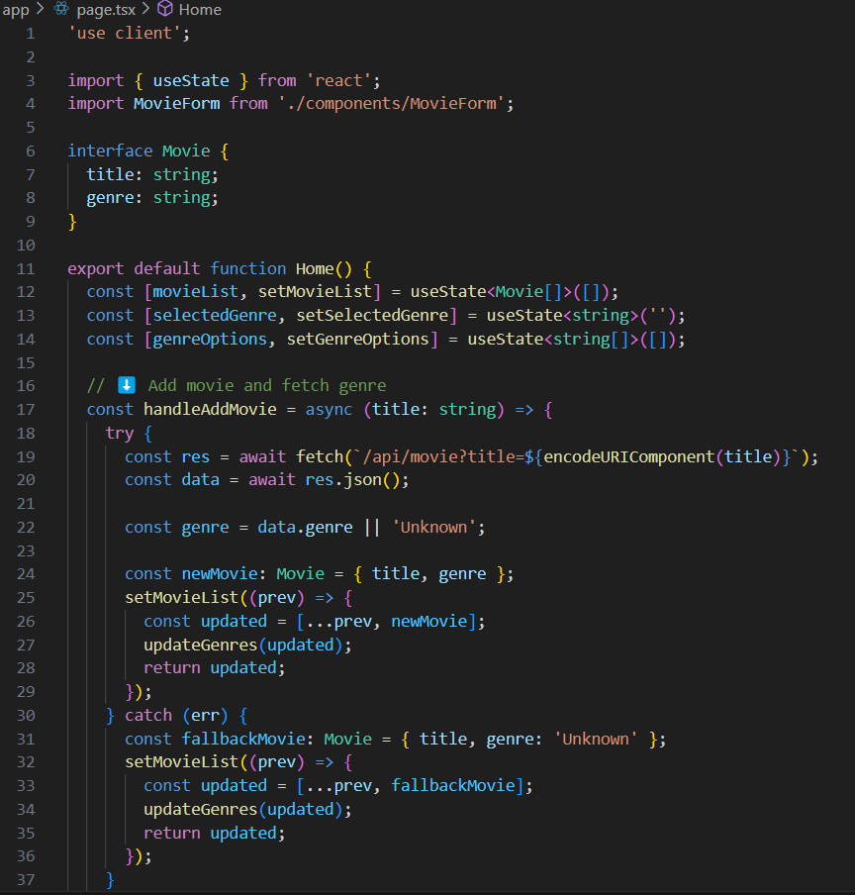

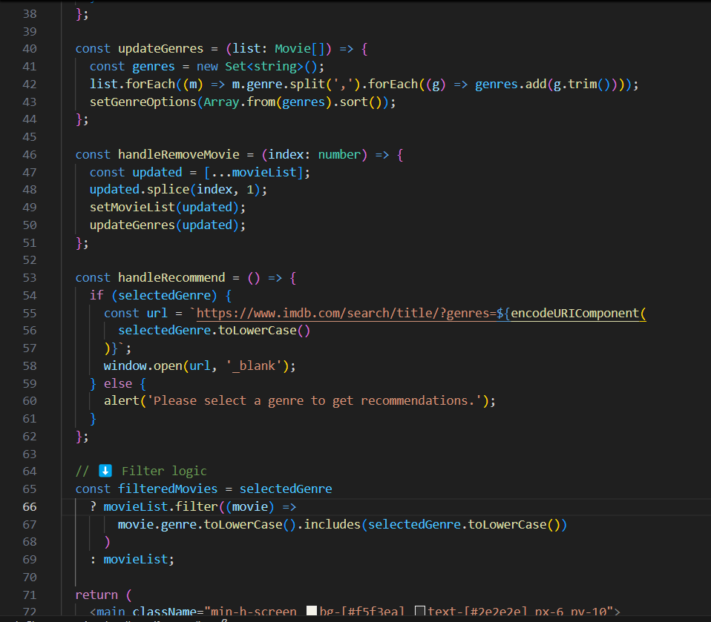
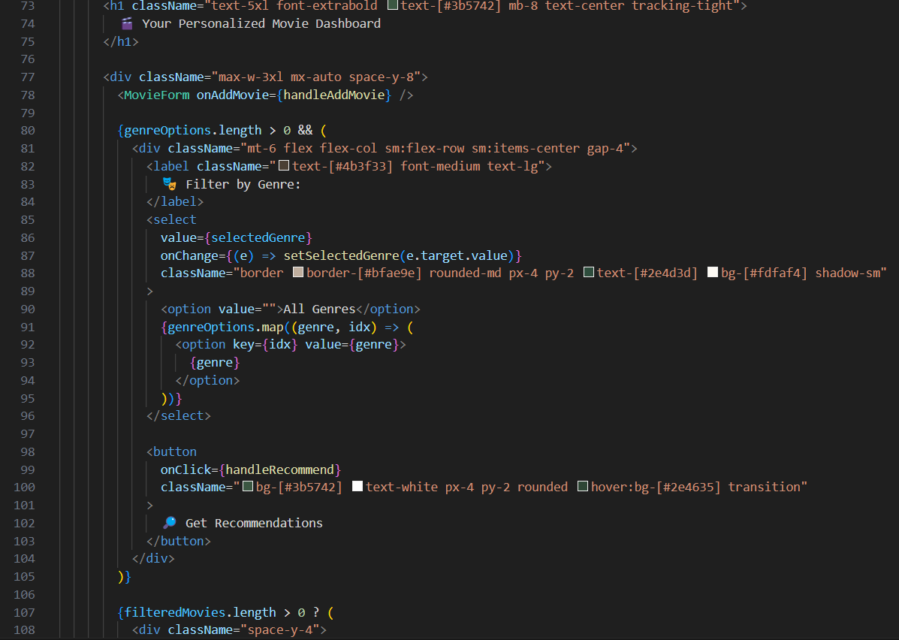
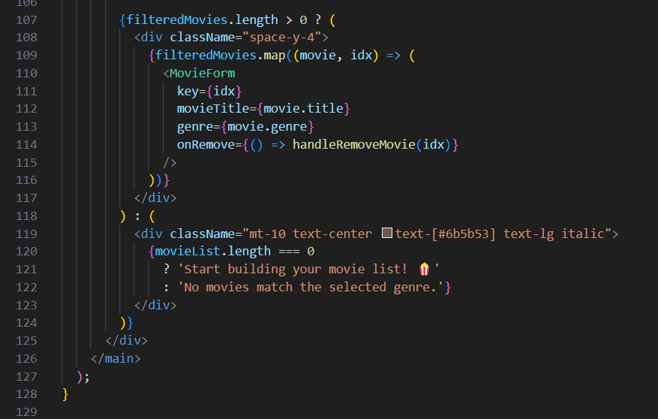

APPENDICES-II
Outputs

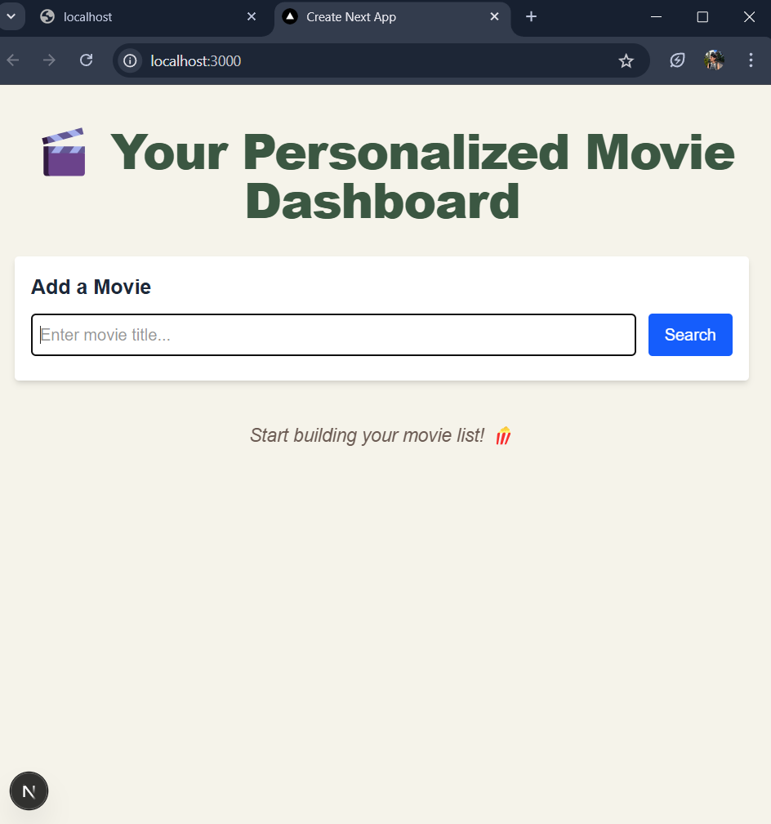

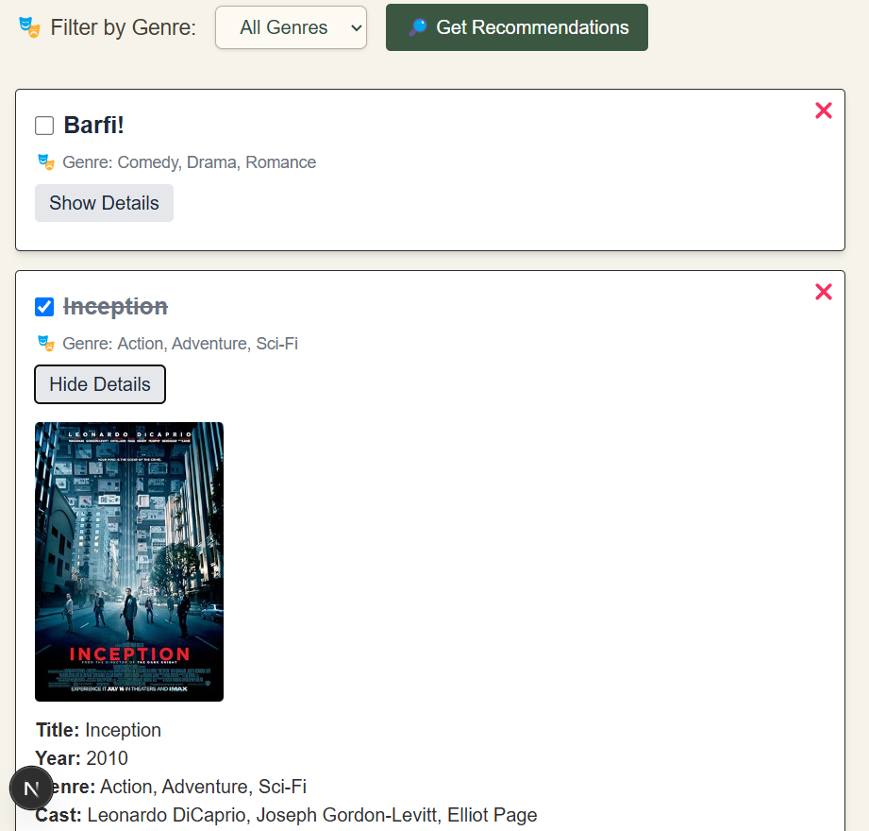
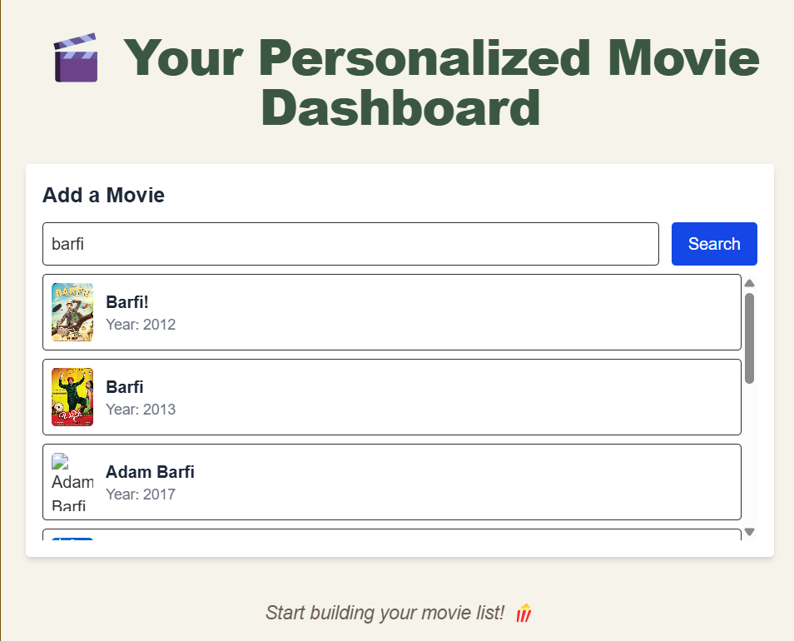

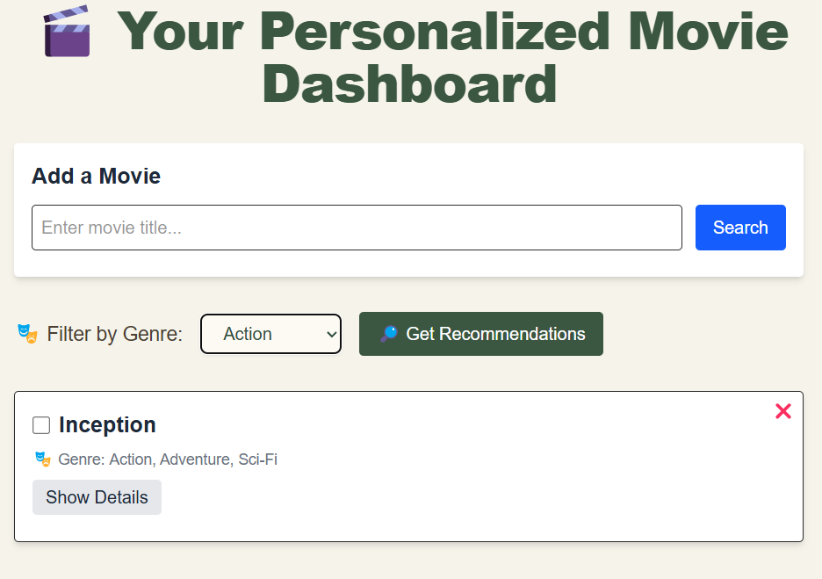
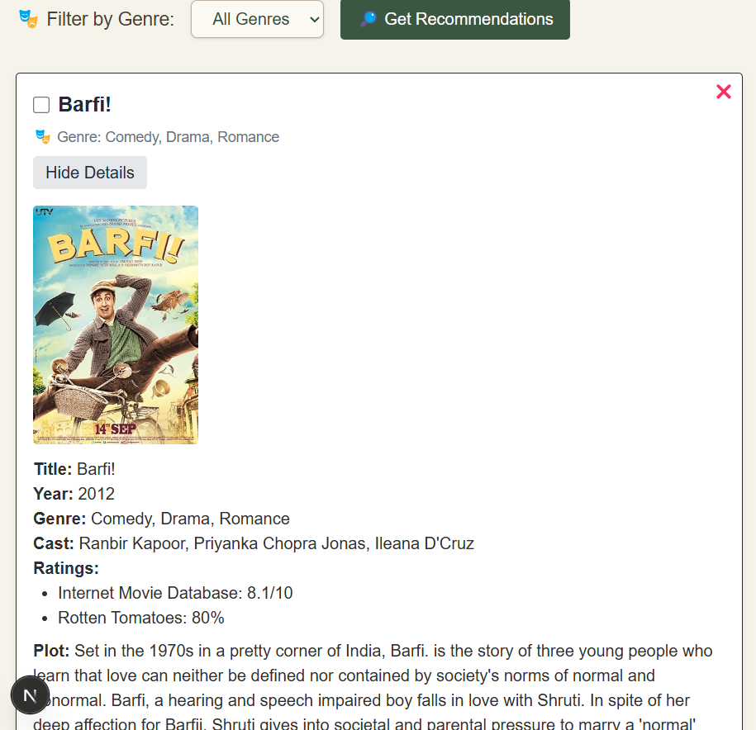

PICTURE WITH THE GUIDE

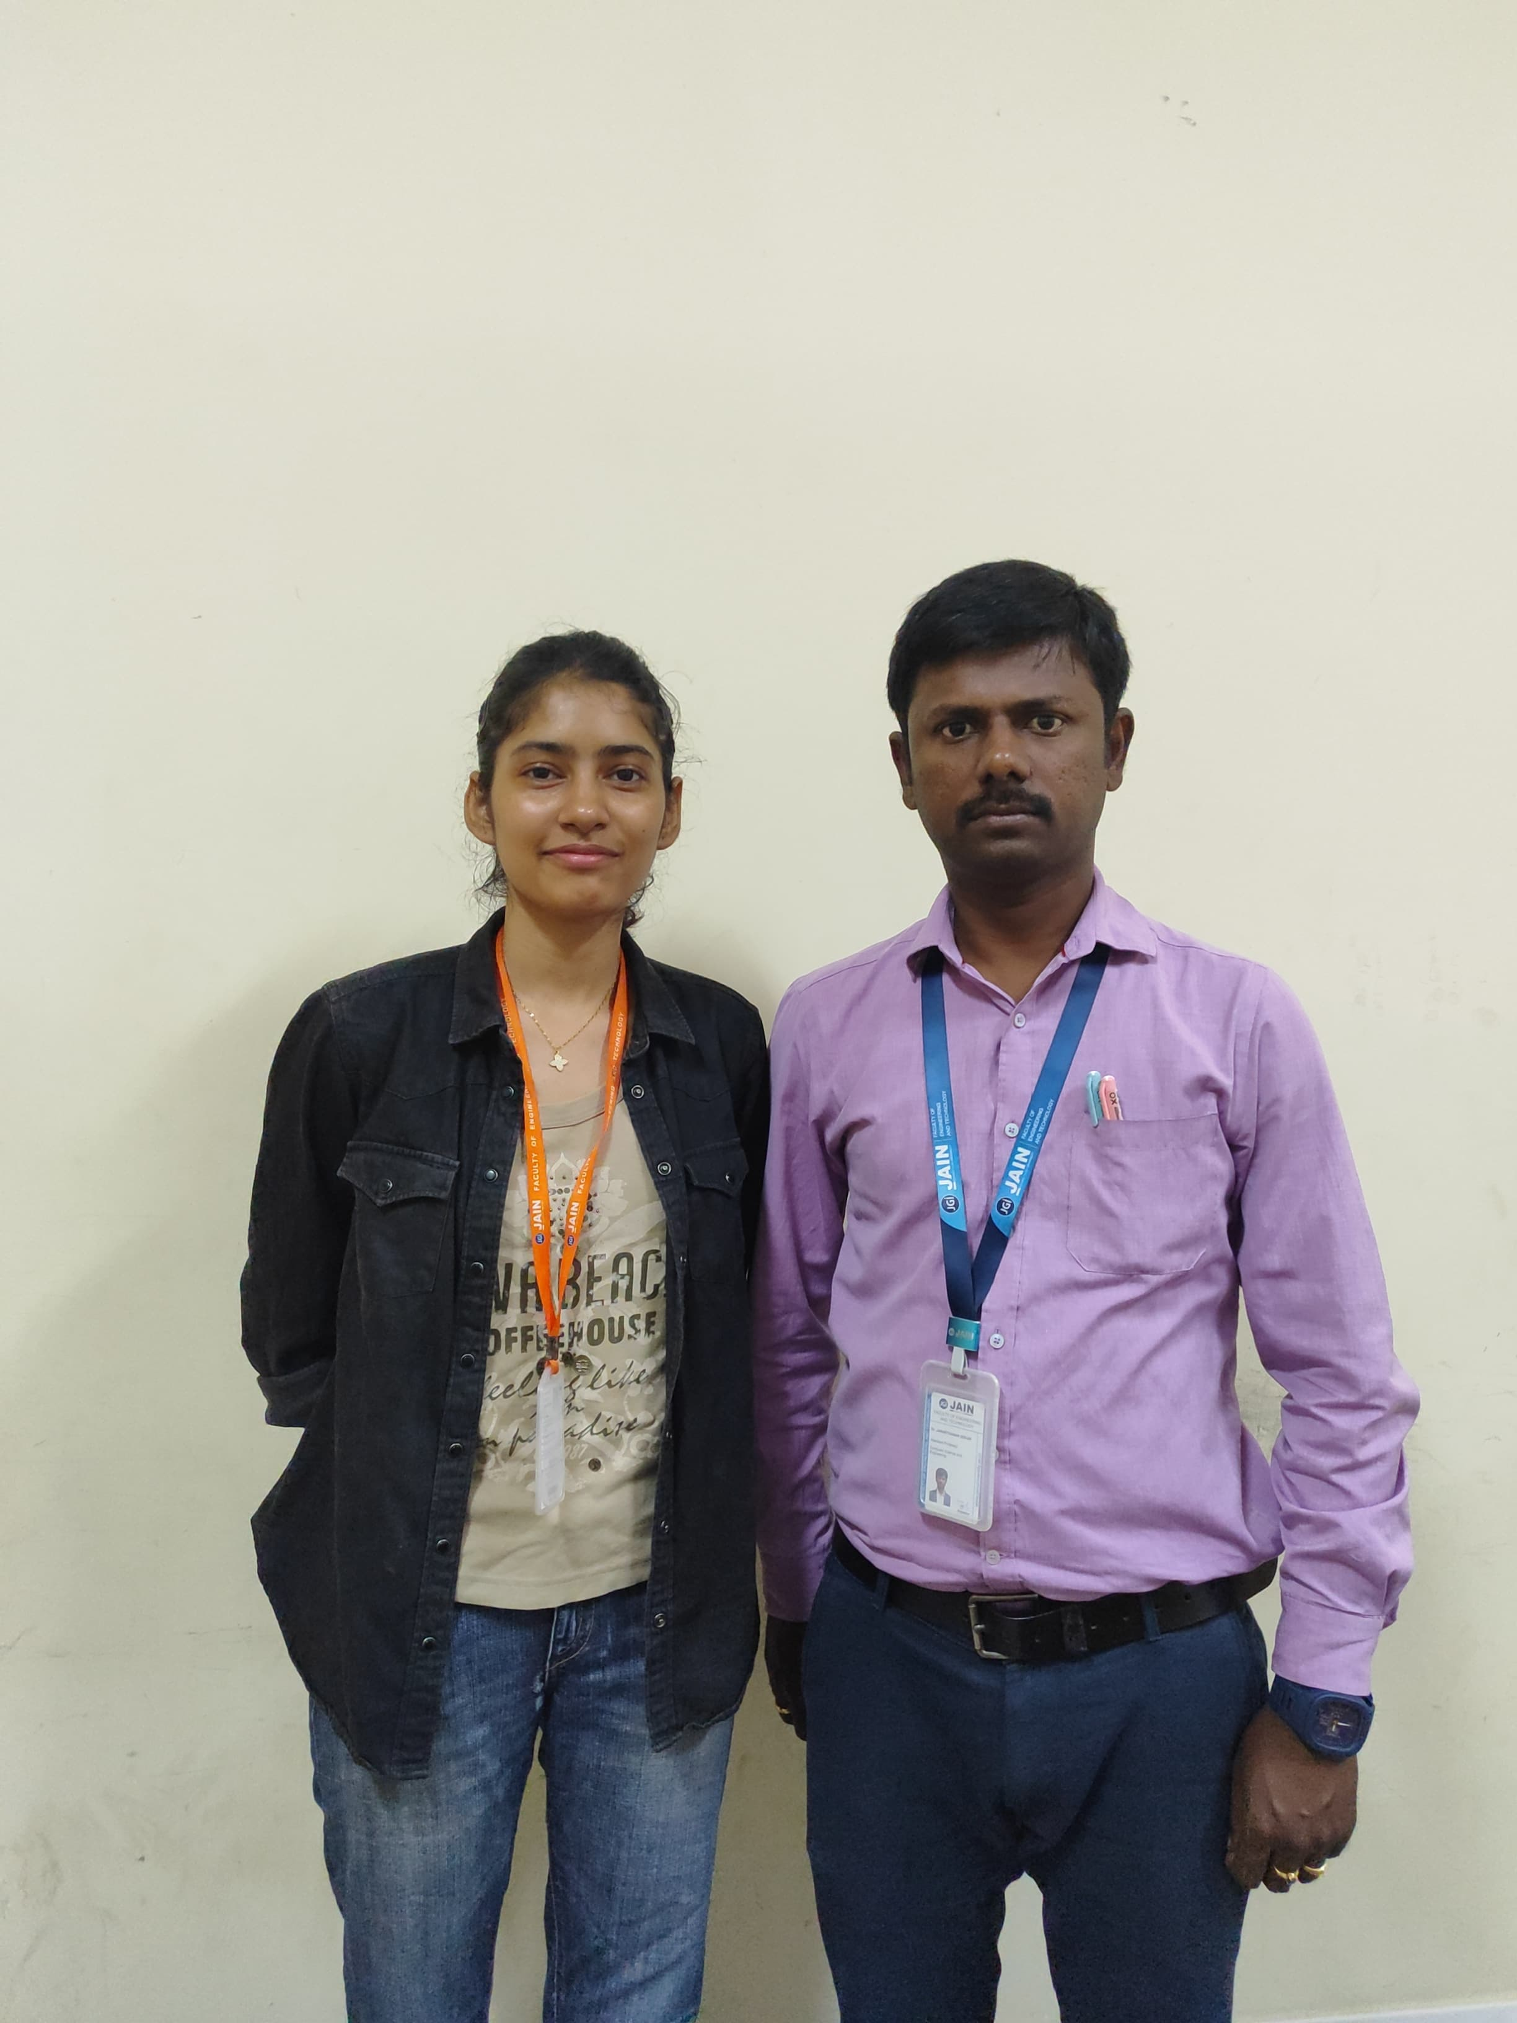

INFORMATION REGARDING STUDENT

Student name | Email id | Permanent Address | Phone Number | Placement Details | Photograph
Darshika Mishra | 22btrsn011@jainuniversity.ac.in | Vishnupuri colony, Church road, Aliganj. Lucknow | 6392582265 | - | 

